Security Engineer

Introduction to Cryptography

**Task 1:**

<https://www.quipqiup.com/>

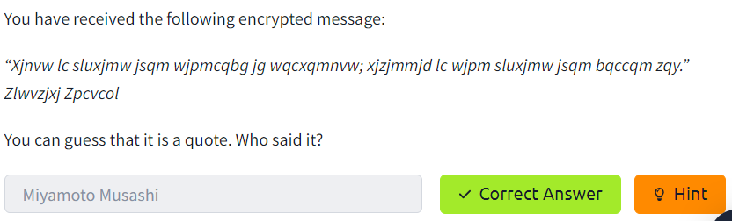

**Task 2:**

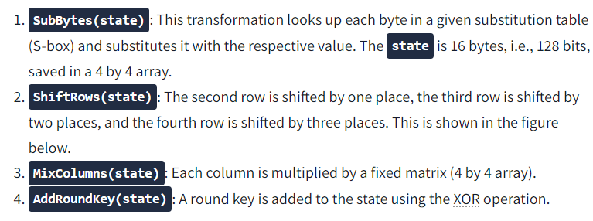

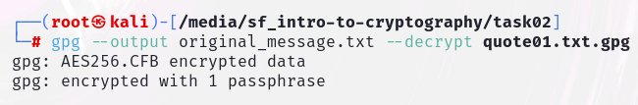

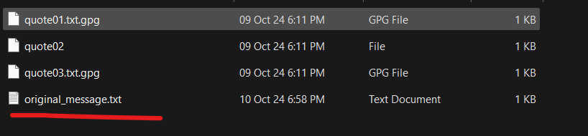

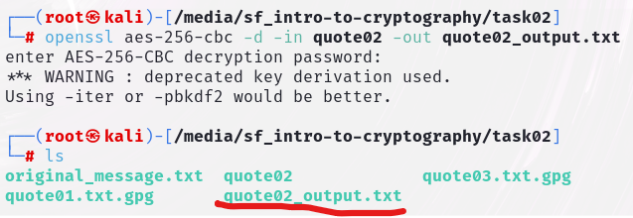

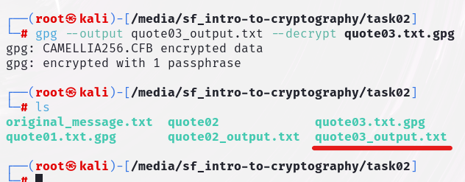

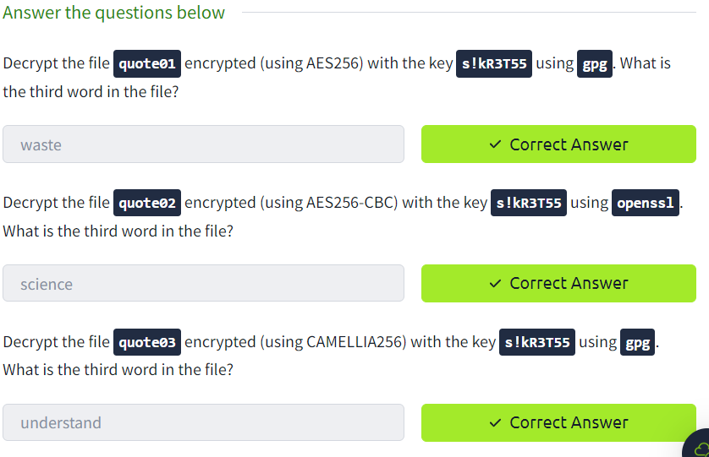

**Task 3:**

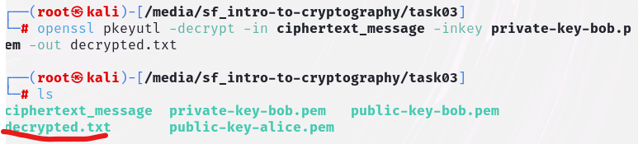

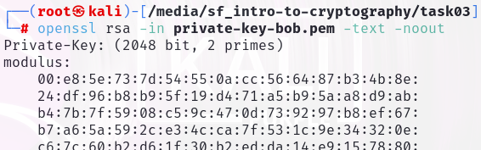

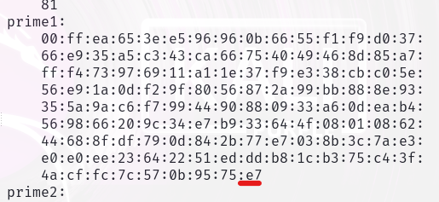

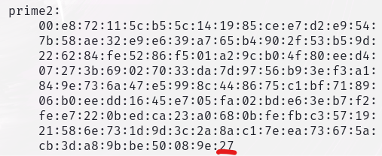

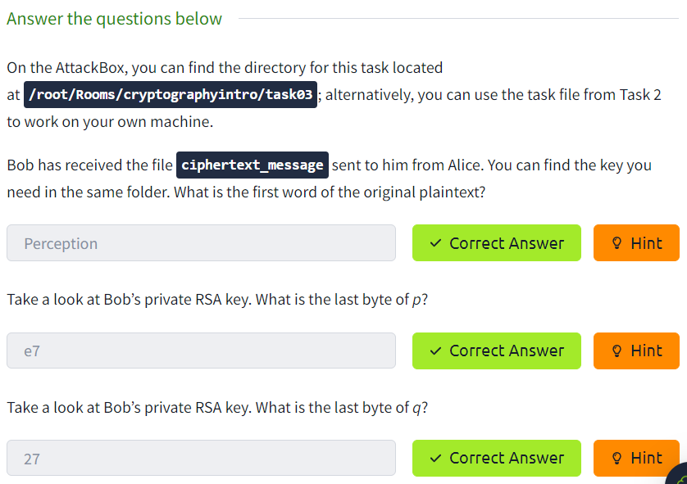

**Task 4:**

**Task 5:**

**Task 6:**

**Task 7:**

**Task 8:**